**PACKAGE MANAGEMENT RPM**

**What is RPM?**

* The RPM Package Manager (RPM) is a powerful package management system used by Red Hat Linux and its derivatives such as CentOS and Fedora.
* RPM also refers to the rpm command and .rpm file format.
* An RPM Package consists of an archive of files and metadata including information such as dependencies and install location.

**PACKAGE SYNTEX**

* Package Name-version-Release-Architecture-Extension

**EXAMPLES:**

**texlive-luahbtex-20200406-25.el9.x86_64.rpm**

* texlive- luahbtex 🡪 Package Name
* 20200406 🡪 version
* 25.e19 🡪 Release
* X86_64 🡪 Architecture
* .rpm 🡪 Extension

**How to Install an RPM Package?**

**Syntax:**

* rpm -ivh waypipe-0.8.2-1.el9.x86_64.rpm
* i : install a package
* v : verbose
* h : print hash marks as the package archive is unpacked.

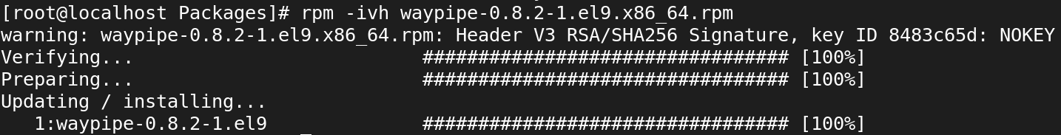

**How to List All Installed RPM Packages?**

**SYNTAX:**

* rpm -qa
* q 🡪 Query
* a 🡪 queries all installed packages

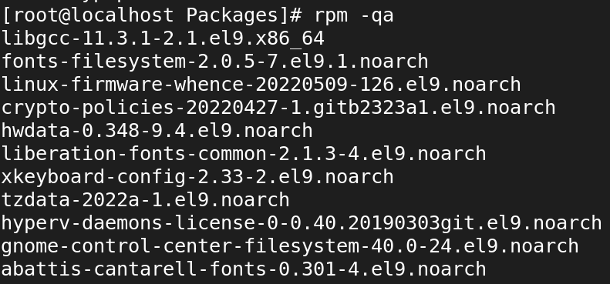

**How to Any Specific Installed RPM Packages?**

**SYNTAX:**

* rpm -qa passwd

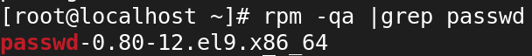

**How to check dependencies of RPM Package before Installing?**

**SYNTAX:**

* rpm -qpR waypipe-0.8.2-1.el9.x86_64.rpm
* q 🡪 Query a package
* p 🡪 List capabilities this package provides.
* R 🡪 List capabilities on which this package depends.

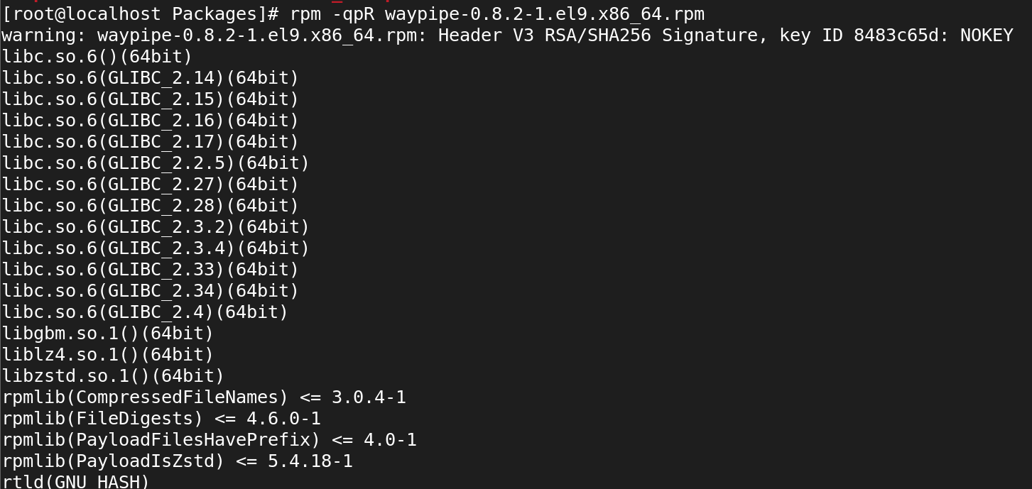

**How to List all files of an installed RPM package?**

**SYNTAX:**

* rpm -ql httpd

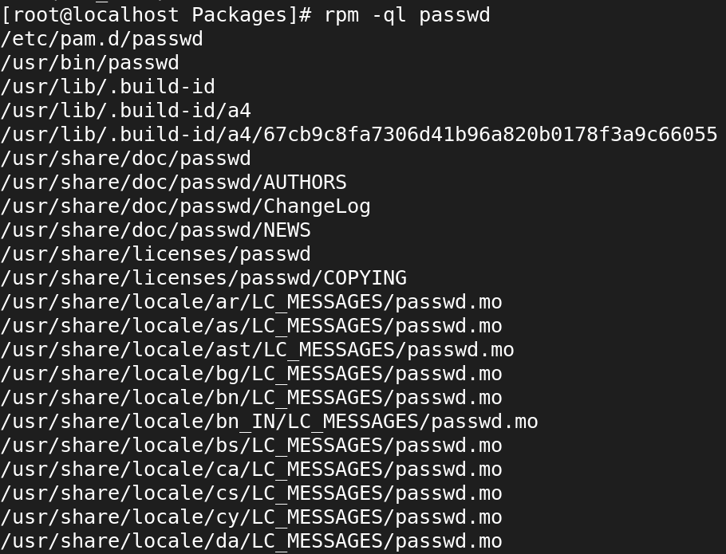

**How to List Recently Installed RPM Packages?**

**SYNTAX:**

* rpm -qa --last

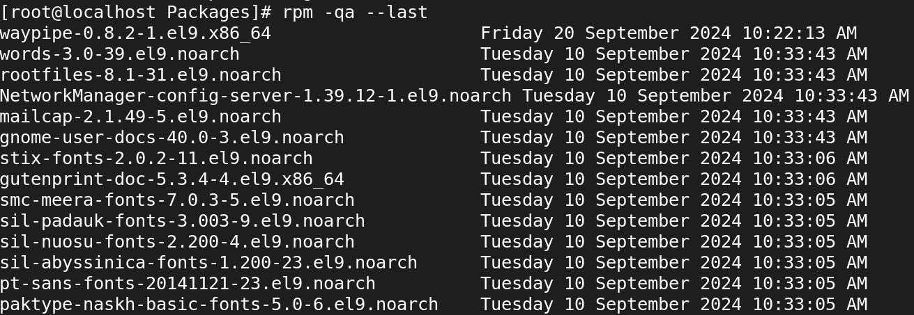

**How to Remove an RPM Package?**

**SYNTAX:**

* rpm -evv httpd

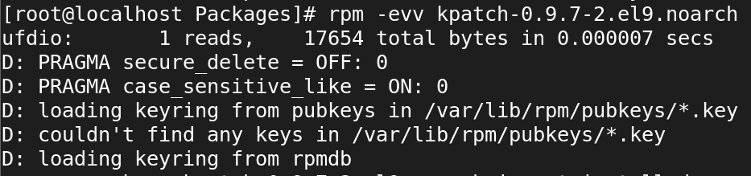

* rpm -evh kpatch-0.9.7-2.el9.noarch

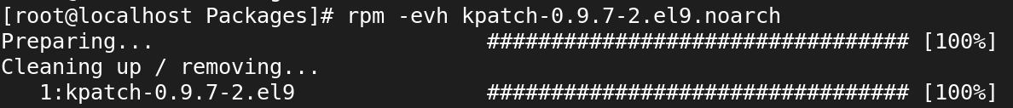

**How to Query a file that belongs which RPM Package?**

**SYNTAX:**

* rpm -qf /usr /bin/mkdir



**How to Query an Information of Installed RPM Package?**

**SYNTAX:**

* rpm -qi kpatch-0.9.7-2.el9.noarch

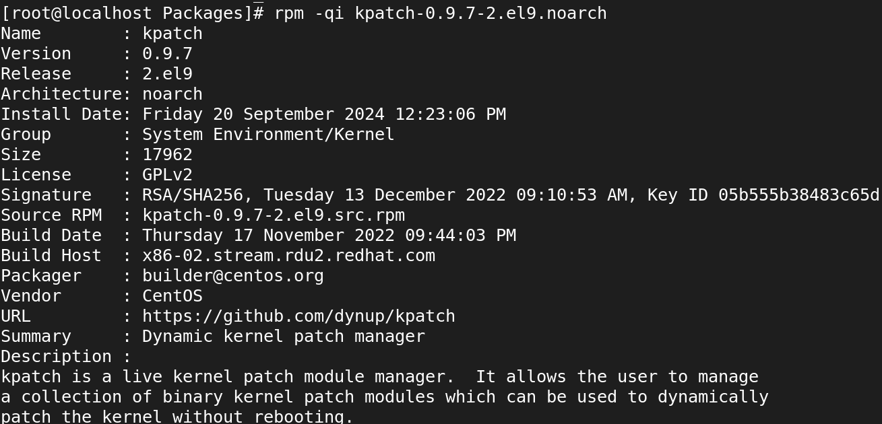

**How to Query documentation of Installed RPM Package?**

**SYNTAX:**

* **rpm -qdf /usr/bin/vstat**

